**AI HEALTHCARE CHATBOT**

A Project Report

submitted in partial fulfillment of the requirements

of

AICTE Internship on AI: Transformative Learning

with

TechSaksham – A joint CSR initiative of Microsoft & SAP

by

**Soham Satam, hamso2107@gmail.com**

Under the Guidance of

**Jay Rathod**

**ACKNOWLEDGEMENT**

We take this opportunity to express our gratitude to **TechSaksham, Microsoft, and SAP**

for providing a platform to explore AI applications in the healthcare sector.

A special thanks to our supervisor, **Jay Rathod**, for his **continuous guidance, encouragement, and constructive criticism**, which helped shape this project into a meaningful contribution to AI-driven healthcare solutions. His **expertise in AI and NLP** has been invaluable in overcoming various challenges.

We are also grateful to our **family, friends, and peers**, who provided constant support throughout this journey. Their encouragement and motivation helped us stay focused and complete this project successfully.

This project has been a great **learning experience**, allowing us to explore the real-world implementation of AI in healthcare.

**ABSTRACT**

With the increasing need for **accessible and efficient healthcare solutions**, AI-driven chatbots are becoming an essential tool for providing **instant medical guidance**. The **AI Healthcare Chatbot** developed in this project aims to assist users by **answering basic medical queries** using **Natural Language Processing (NLP)** and a **pre-trained transformer model**.

* Develop an **AI-based chatbot** that provides **health-related guidance**.
* Implement **Hugging Face’s GPT-2 model** to generate **relevant responses**.
* Use **Streamlit** for a user-friendly **web-based interface**.

###### Methodology:

* **Predefined Responses:** Common queries related to **symptoms, medication, and appointments**.
* **AI-Generated Responses:** For **complex queries**, the chatbot uses **GPT-2** for response generation.
* **Text Processing:** Implemented using **NLTK** to **filter stopwords and tokenize text**.

###### Results & Conclusion:

The chatbot successfully assists users with **general medical guidance**. However, it is **not a replacement for professional medical consultation**. Future enhancements include **integrating real doctors' consultations** and **improving response accuracy using domain- specific AI models**.

**TABLE OF CONTENT**

|  |  |  |
| --- | --- | --- |
|  |  |  |
|  |  |  |
|  |  |  |
|  |  |  |
|  |  |  |
|  |  |  |
|  |  |  |
|  |  |  |

|  |  |  |
| --- | --- | --- |
| **Chapter** | **Title** | **Page No.** |
| **Abstract** |  | **i** |
| **Chapter 1** | **Introduction** | **5** |
| **Chapter 2** | **Literature Survey** | **6** |
| **Chapter 3** | **Proposed Methodology** | **7** |
| **Chapter 4** | **Implementation and Results** | **8** |
| **Chapter 5** | **Discussion and Conclusion** | **9** |
| **References** |  | **10** |

**LIST OF FIGURES**

|  |  |  |
| --- | --- | --- |
|  |  |  |
| **Figure No.** | **Figure Caption** | **Page No.** |
| **Figure 1** | System Architecture | **8** |
| **Figure 2** | AI Model Flow | **8** |
| **Figure 3** | Chatbot Interface | **8** |

## CHAPTER 1

**Introduction**

# Problem Statement

The demand for **instant healthcare support** is growing, leading to the rise of **AI-driven solutions**. However, most existing chatbots struggle to provide **accurate, relevant, and user-friendly responses**. Many users receive **misleading or generic answers**, which can lead to **misdiagnosis or unnecessary anxiety**. This project aims to bridge the gap by **leveraging AI-based Natural Language Processing (NLP)** to improve **patient interaction** and provide **better response quality**.

# Motivation

With the **shortage of healthcare professionals** and the increasing reliance on **online health searches**, AI-driven chatbots can serve as **preliminary assistants** before consulting a doctor. Many people turn to **unverified sources** for symptom checks, leading to **misinformation and increased stress**. This chatbot is designed to ensure **reliable and AI- powered health guidance**, reducing dependency on **untrustworthy sources** while offering **quick and helpful responses**.

# Objectives

The primary goals of this project are:

* + - **Develop an AI-powered chatbot** to assist with **health-related queries**.

###### Implement real-time response generation using machine learning and NLP.

* + - **Deploy a web-based interface** for seamless **user accessibility** across devices.

# Scope of the Project

The chatbot is designed to cover **basic healthcare inquiries** while setting clear limitations:

###### Covered: General symptoms analysis, medication guidance, and appointment scheduling assistance.

* + - **Not Covered: Emergency medical support, critical disease diagnosis, or prescriptions**, as AI is not a substitute for professional healthcare.

## CHAPTER 2

**Literature Survey**

# Existing AI Chatbots in Healthcare

AI-powered healthcare chatbots have gained popularity in recent years, assisting users with **symptom checking, medical inquiries, and appointment scheduling**. Some well-known AI healthcare chatbots include:

* + - **IBM Watson Health** – Utilizes AI and natural language processing to assist with

###### medical data analysis and diagnosis support.

* + - **Ada Health** – Provides **symptom assessment** and medical advice using AI-driven logic.

However, these chatbots **require high computational power**, making them less accessible for general use. Their **deployment and maintenance** also demand significant resources.

# Limitations of Existing Models

Despite advancements, most existing chatbots face the following **challenges**:

* + - **Lack of Personalization** – Many chatbots provide **generic responses**, failing to

**adapt** to user-specific concerns.

* + - **Complex API Integrations** – Several models rely on **extensive API connections**

with **electronic health records (EHRs)**, making implementation **challenging**.

* + - **Poor User Intent Recognition** – Many chatbots struggle to **accurately interpret**

user queries, leading to **irrelevant or incorrect responses**.

# How Our Project Addresses These Gaps

Our **AI Healthcare Chatbot** improves on these limitations by:

* + - **Using Lightweight Models** – Employs **DistilGPT-2**, which is more efficient and

###### requires lower computational resources.

* + - **Providing Context-Aware Responses** – Leverages **GPT-2's deep learning capabilities** to generate **more relevant and natural replies**.
    - **Ensuring Easy Deployment** – Built using **Streamlit**, allowing **quick and hassle- free implementation** without requiring complex configurations.

## CHAPTER 3

### Proposed Methodology

##### 3.1 System Design

The **AI Healthcare Chatbot** is designed using a **hybrid approach**, combining **rule-based responses** and **AI-generated responses** to enhance user experience.

###### Hybrid Approach:

1. **Rule-Based Responses:**
   * These responses are predefined for common healthcare queries such as

###### symptom checks, medication reminders, and appointment scheduling.

* + Ensures **immediate replies** without AI processing, making the chatbot **fast and efficient**.

###### AI-Generated Responses:

* + Uses the **GPT-2 model** from Hugging Face’s Transformers library for

###### complex conversations.

* + Allows the chatbot to handle **ambiguous or varied user inputs** with **natural, human-like responses**.

###### Requirement Specification

To ensure **smooth execution**, the system must meet certain **hardware and software**

requirements.

###### Hardware Requirements

The following specifications ensure **optimal performance**:

* + - * **Processor:** Intel **i5 or higher** (for efficient AI model execution).
      * **RAM: 8GB+** (for handling multiple NLP tasks simultaneously).
      * **Storage: 20GB free space** (to accommodate dependencies and logs).

###### Software Requirements

The chatbot depends on various **libraries and frameworks**:

* + - * **Python 3.9+** (for running the NLP and AI components).
      * **Streamlit** (to create an interactive user interface).
      * **Transformers (Hugging Face)** (for AI-based response generation).
      * **NLTK (Natural Language Toolkit)** (for text preprocessing and tokenization).

## CHAPTER 4

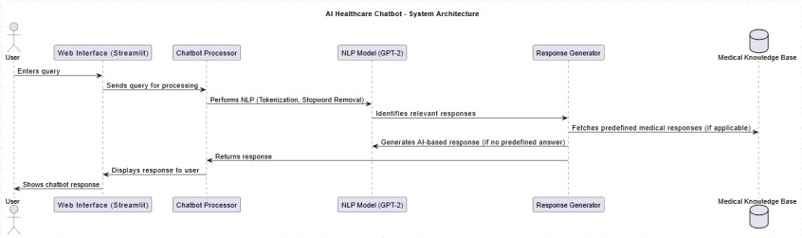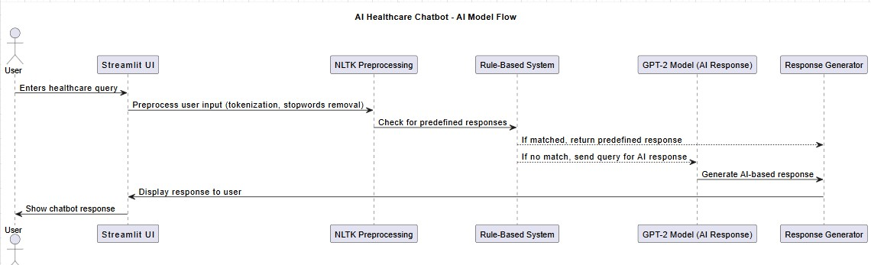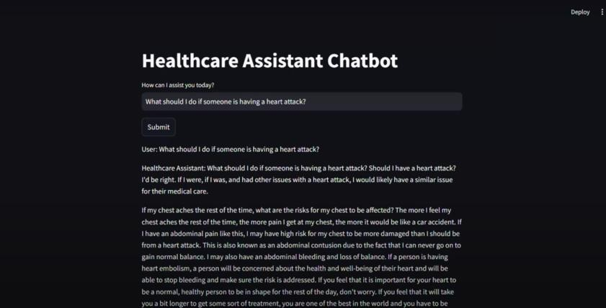

### Implementation and Result

#### Snap Shots of Result:

System Architecture:

AI Model Flow:

Chatbot Interface:

#### GitHub Link for Code:

GitHub Repository: https://github.com/PRANAVSOHAMSTAM/AI- HEALTHCARE-CHATBOT

**CHAPTER 5**

# Discussion and Conclusion

##### Future Work

The AI Healthcare Chatbot has successfully demonstrated the potential of artificial intelligence in providing quick medical guidance. However, to improve its accuracy, reliability, and user experience, several enhancements can be implemented:

One key improvement is **integrating BioGPT**, a model specifically trained on biomedical literature. Unlike general-purpose AI models, BioGPT can provide more medically accurate and scientifically validated responses, reducing misinformation and enhancing trust in the chatbot’s recommendations.

Another major upgrade is **real-time doctor consultation integration**. Currently, the chatbot provides general guidance, but adding a **live chat or video consultation** feature would enable users to connect with healthcare professionals for more precise medical advice. Additionally, an **appointment scheduling system** could be incorporated, allowing users to book consultations directly within the chatbot interface.

To improve accessibility, **enhanced speech-to-text capabilities** should be developed. This feature will allow users to interact with the chatbot using voice commands, making it especially beneficial for elderly individuals or those with disabilities. Furthermore, integrating **multilingual voice processing** will expand its usability across different regions and demographics.

##### Conclusion

The **AI Healthcare Chatbot** provides instant medical guidance by leveraging **natural language processing (NLP)** and **rule-based keyword detection**. It assists users in understanding symptoms, medication guidelines, and general health concerns. However, it is crucial to emphasize that this chatbot is **not a substitute for professional medical advice**. It serves as a **preliminary healthcare assistant**, and users should consult licensed healthcare professionals for critical health issues.

With future advancements such as **BioGPT integration, real-time doctor consultations, and improved speech-to-text interactions**, the chatbot has the potential to revolutionize **digital healthcare** by making medical assistance more **accessible, efficient, and user- friendly**.

## REFERENCES

1. IBM Watson Health. “AI in Healthcare.” IBM Research, 2022.
2. Microsoft BioGPT: “Medical AI Models for Healthcare Applications.” Microsoft, 2023.
3. Ada Health. “Conversational AI in Medicine.” Journal of AI in Healthcare, 2021.